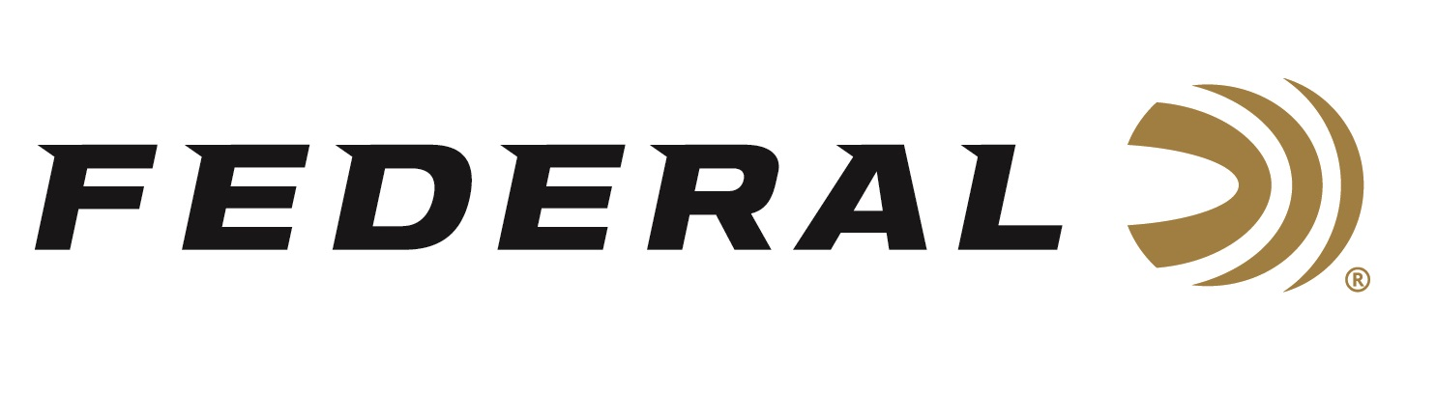

FOR IMMEDIATE RELEASE

Federal Sponsored Shooter Derrick Mein Dominates the Caribbean Cup

ANOKA, Minnesota – February 10, 2021 – Team Federal congratulates Derrick Mein on an impressive weekend at the Vero Beach Clay Shooting Sports complex in Vero Beach, FL. Mein’s list of accomplishments from the February 3-8, 2021 Caribbean Cup include winning the Caribbean Cup championship over 106 entrants, FITASC Runner-up, Super Sport Champion, 20-28-410 Champion, Ironman Champion and Mein claimed the Federal Challenge Championship.

“I performed very well,” said Derrick Mein considering this was the first tournament of the season for the veteran and USA Shooting team member. Mein broke 192 clays out of 200 to win the Caribbean cup as well breaking 96 out of 100 to claim the Federal Challenge Championship. “I was aided by the hard breaks delivered from the Federal ammo I used over the weekend in 12, 20, 28 and .410 gauges,” said Mein.

Mein uses the Federal Premium Gold Medal Paper loads for his 12-gauge events and Top Gun Sporting 20, 28, and .410 loads for the sub-gauge specific competitions. In the sub-gauge events, Mein was equally as impressive breaking 92 percent of the targets he faced during the competitions.

Federal ammunition can be found at dealers nationwide or purchased online direct. For more on Federal ammunition, visit www.federalpremium.com.

Press Release Contact: JJ Reich
Senior Manager – Press Relations
E-mail: VistaPressroom@VistaOutdoor.com

About Federal Ammunition
Federal, headquartered in Anoka, MN, is a brand of Vista Outdoor Inc., an outdoor sports and recreation company. From humble beginnings nestled among the lakes and woods of Minnesota, Federal Ammunition has evolved into one of the world's largest producers of sporting ammunition. Beginning in 1922, founding president, Charles L. Horn, paved the way for our success. Today, Federal carries on Horn's vision for quality products and service with the next generation of outdoorsmen and women. We maintain our position as experts in the science of ammunition production. Every day we manufacture products to enhance our customers' shooting experience while partnering with the conservation organizations that protect and support our outdoor heritage. We offer thousands of options in our Federal Premium and Federal® lines-it's what makes us the most complete ammunition company in the business and provides our customers with a choice no matter their pursuit.

